|  |  |  |  |  |  |  |
| --- | --- | --- | --- | --- | --- | --- |
| **Group Process Evaluation Form** | | | | | | |
| Individually, reflect on your group’s dynamics and – anonymously – rate them according to each of the following variables (using a scale from 1 to 5).  As a group, discuss the results and brainstorm concrete ways to improve your group processes. | | | | | | |
| **Goals** | | | | | | |
| Goals are unclear or poorly understood, resulting in little commitment to them. | 1 | 2 | 3 | 4 | 5 | Goals are clear, understood, and have the full commitment of team members. |
| **Openness** | | | | | | |
| Members are guarded or cautious in discussions. | 1 | 2 | 3 | 4 | 5 | Members express thoughts, feelings, and ridicule ideas freely. |
| **Mutual Trust** | | | | | | |
| Members are suspicious of one another’s motives. | 1 | 2 | 3 | 4 | 5 | Members trust one another and do not fear ridicule or reprisal. |
| **Attitudes Toward Difference** | | | | | | |
| Members smooth over differences and suppress or avoid conflict. | 1 | 2 | 3 | 4 | 5 | Members feel free to voice differences and work through them. |
| **Support** | | | | | | |
| Members are reluctant to ask for or give help. | 1 | 2 | 3 | 4 | 5 | Members are comfortable giving and receiving help. |
| **Participation** | | | | | | |
| Discussion is generally dominated by a few members. | 1 | 2 | 3 | 4 | 5 | All members are involved in discussion. |
| **Decision-making** | | | | | | |
| Decisions are made by only a few members. | 1 | 2 | 3 | 4 | 5 | All members are involved in decision-making. |
| **Flexibility** | | | | | | |
| The group is locked into established rules and procedures that members find difficult to change. | 1 | 2 | 3 | 4 | 5 | Members readily change procedures in response to new situations. |
| **Use of Member Resources** | | | | | | |
| Individuals’ abilities, knowledge and experience is not well utilized. | 1 | 2 | 3 | 4 | 5 | Each member’s abilities, knowledge, and experience are fully utilized. |

Team Member evaluation: Overall my team member was great to work with. They were focused, enthusiastic about the development process, and communicative with most issues. I would definitely work with them again.

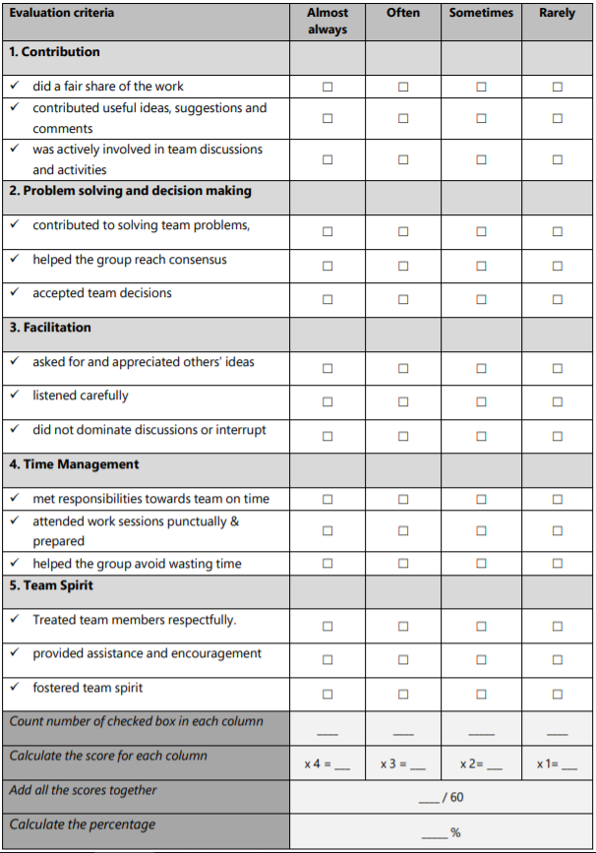

90

54

18

6

36

9

Self-evaluation



90

54

18

36

6

9

Self-reflection: Overall, I feel as if I were equally as good of a team member as the other team member. We both shared similar amounts of motivation, enthusiasm, and knowledge of the subjects we were tested on. It was an enjoyable process and I would happily do it again.